PRESS RELEASE
Embargoed for release until April 9th, 2020
Contact: Sébastien Mourey
Phone: +337 68 61 30 25
Email: sebastien@inookta.com

inookta teams up with international artists to launch Soundscapes, a new mobile app to reconnect with nature

Available now on the Apple App Store, Soundscapes provides hundreds of immersive recordings and sound creations inspired by nature, to rediscover the soothing power of listening to the sounds of the wild.

MONTREAL, CANADA (April 9, 2020) – inookta studio inc. today announced the release of Soundscapes: a new iOS app to reconnect with nature by exploring a collection of hundreds of immersive and high-quality soundscapes produced by passionate and renowned artists from around the world. Users are instantly transported in the middle of the toucans in the Brazilian Amazon rainforest, at the foot of a glacier calving in Antarctica, or on the edge of an active volcano in Ethiopia.

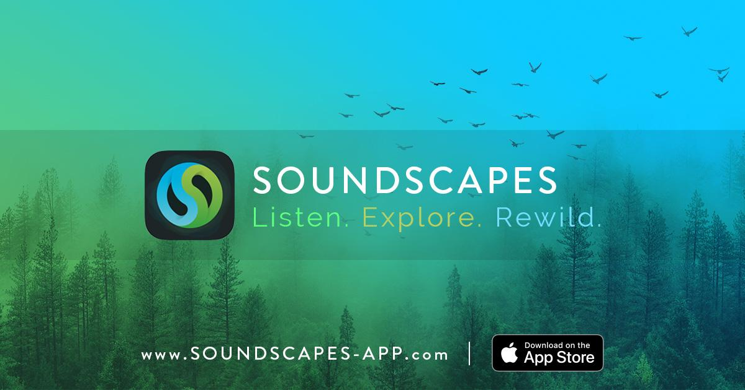

“Listening is an essential resource that can open our minds to changes that are occurring now, as well as those to come.” indicated Fernand Deroussen, field recordist and composer.

The need to listen to the world in which we live seems to be more essential every day, and it is in this context that sound ecology and field recording practices have developed. Around the world, passionate artists explore forests, deserts, winds, ice, the seabed, the interior of tree trunks and anthills, in search of unique and unexpected sounds: the wild world is an infinite source of inspiration.

Soundscapes is:
- Every week new, original and documented soundscapes selected by our team
- The discovery of inspiring artists, their adventures and the ecosystems they explore
- Smart playlists that adapt to the time of day
- The benefits of nature sounds: concentration, relaxation, reduction of stress and anxiety, and the harmful effects these have on our health and that of the people around us.

Price and availability
- Free download on the App Store, worldwide
- After a 30 day free trial, a subscription of $35.99 per year (or $4.49 per month) will allow unlimited streaming and access to all features. These revenues will be shared with the artists and help to cover the development costs of the project.
- Languages: English, French, Japanese and simplified Chinese
- Android and web versions will be developed in the upcoming months

Links
- Download Soundscapes: https://itunes.apple.com/us/app/id1470589737
- Website: https://soundscapes-app.com/
- Press kit (images, screenshots,...): https://soundscapes-app.com/press

About inookta studio inc.
inookta collaborates with talented artists from around the world to create unique and intuitive digital tools for sound exploration. Mobile apps Pure Nature and TaoMix 2 have received several awards and outstanding feedback from millions of users worldwide. https://inookta.com/
For Soundscapes, inookta teams up with Phaune Radio: a webradio that offers a sound and musical exploration of wild worlds, linked to a network of international artists. https://phauneradio.com/

###

Contact
Sébastien Mourey (co-founder of inookta studio inc.)
+337 68 61 30 25
sebastien@inookta.com

